Mohawk College

Software Engineering Project

(Application Building Platform

Handoff & Instructions)

Group 2 – Project 14 (Application Building Platform)

Table of Contents

**Operating Instructions with Screenshots** 3

**Build Instructions** 10

**Special Accounts** 11

**Future Direction** 11

**Operating Instructions with Screenshots**

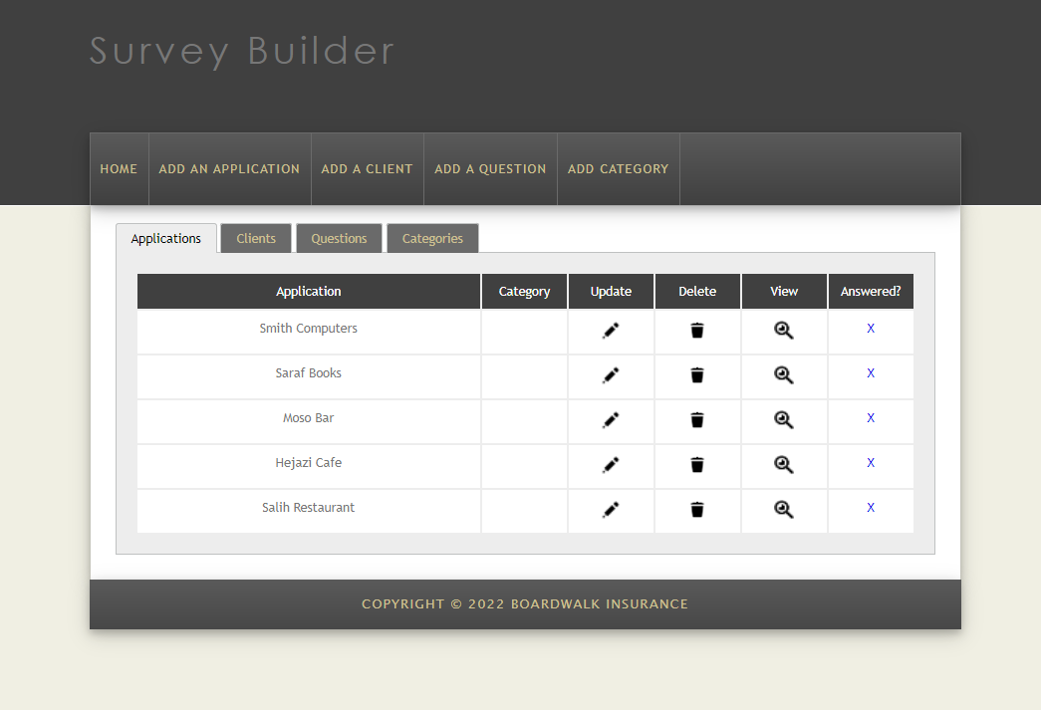

Figure 1: Application Building Platform Homepage (Applications table)

This is the first page a user will see when they open the application. The home page shows four tables of the created “Applications”, “Clients”, “Questions”, and “Categories”. Figure 1 only shows the “Applications” saved in the database. Users may update, or delete, an existing “Application” by clicking on the associated icon.

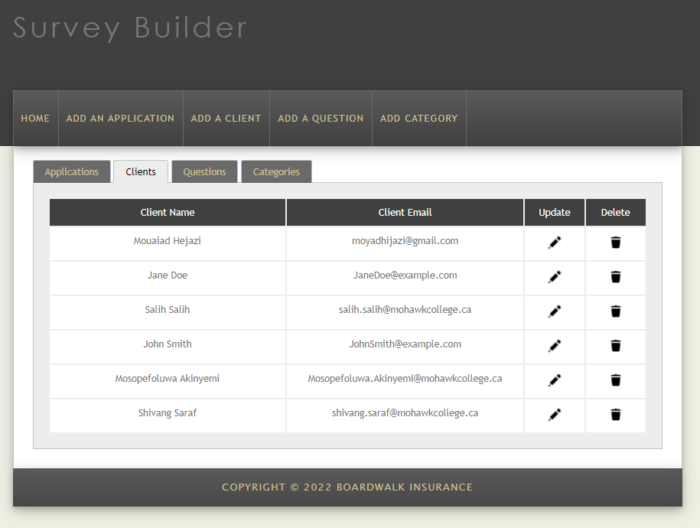

Figure 2: Application Building Platform Homepage (Clients table)

When the user clicks on the “Clients” tab, a table of the clients stored in the database will show. Users may update, or delete, an existing “Client” by clicking on the associated icon.

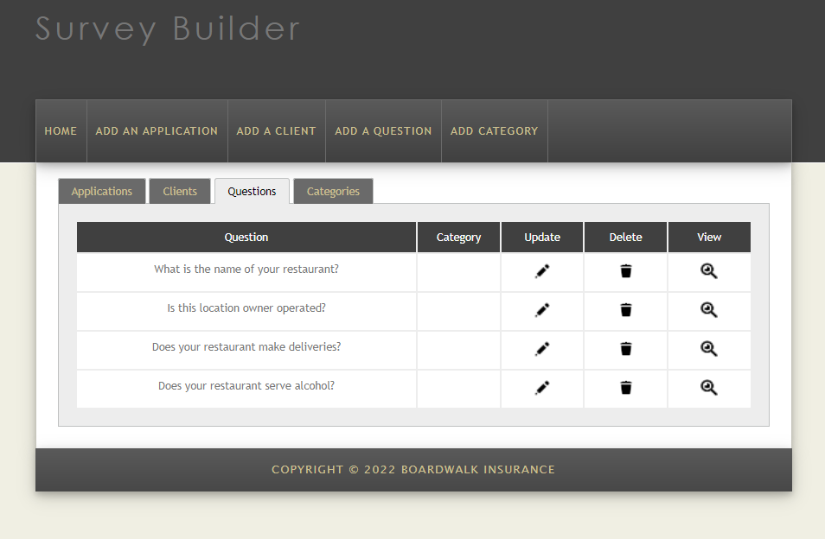

Figure 3: Application Building Platform Homepage (Questions table)

When the user clicks on the “Questions” tab, a table of the “Questions” stored in the database will show. Users may update, or delete, an existing “Question” by clicking on the associated icon.

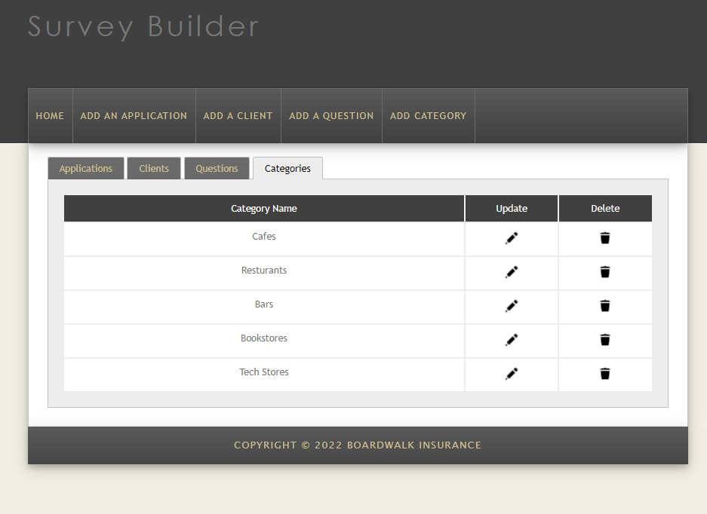

Figure 4: Application Building Platform Homepage (Categories table)

When the user clicks on the “Categories” tab, a table of the “Categories” stored in the database will show. Users may update, or delete, an existing “Category” by clicking on the associated icon.

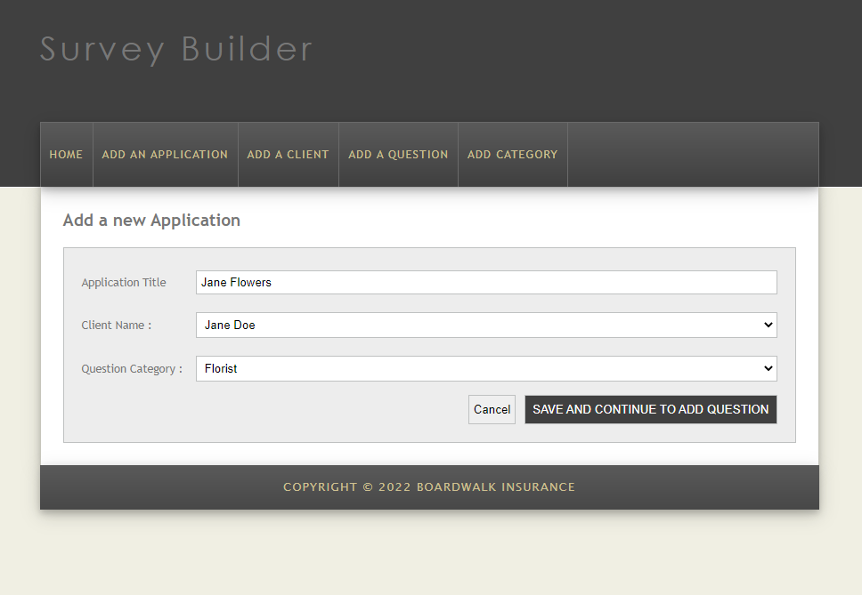

Figure 5: Add an Application Page

This page allows users to insert new “Applications” into the database using existing “Clients” and “Categories”. Users may then click on the “Save and Continue to Add Questions” button to proceed.

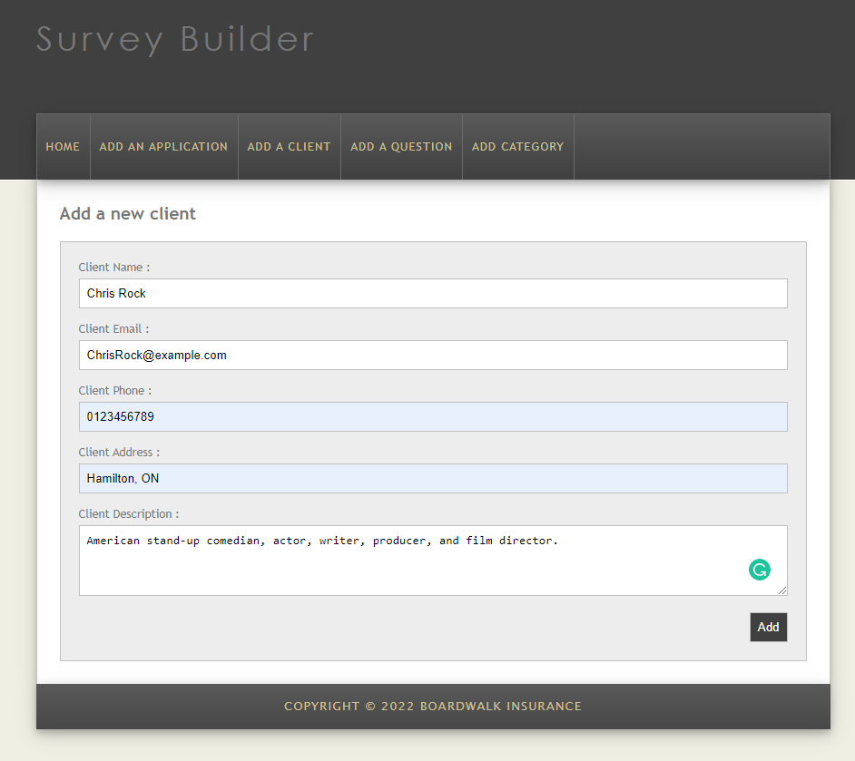

Figure 6: Add a Client Page

This page enables users to insert new “Clients” into the database. Users will have to input a valid client name, email, phone number, address, and description. Users may click on the “Add” button to add the new client.

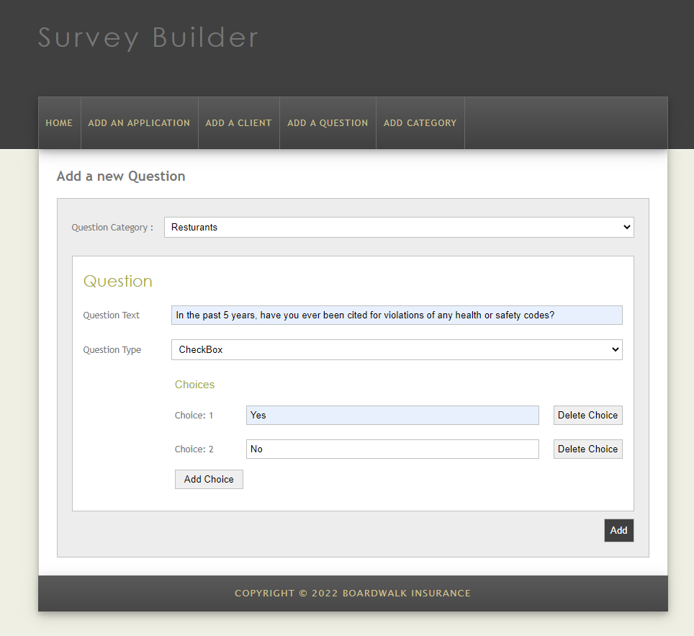

Figure 7: Add a Question Page

This page allows users to insert new “Questions” into the database. Users will have to select a “Question Category”, input a valid “Question Text”, then select a “Question Type” (either a Checkbox or a Text or a Radio) Then they may add the choices. Finally, to add a new question they may click on the “Add” button.

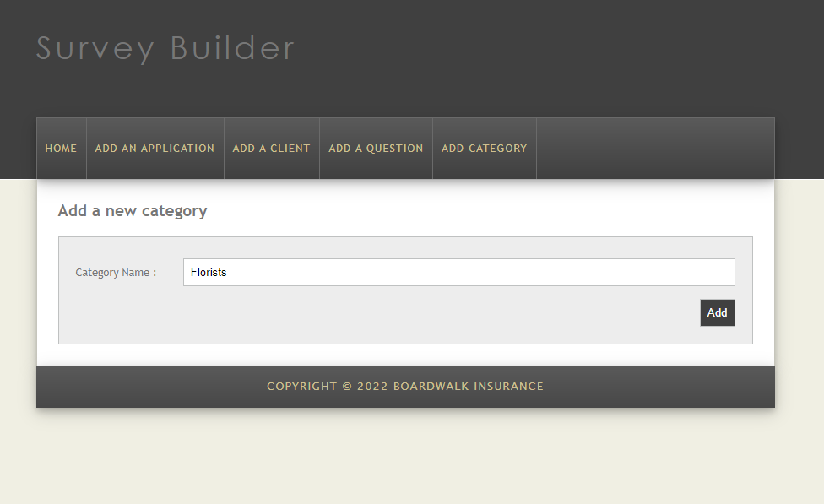

Figure 8: Add a Category Page

This page enables users to insert new “Categories” into the database. Users will have to input a valid category name. They may click on the “Add” button to add the new category.

**Build Instructions**

* Software used to build the application:
  + IDE: Visual Studio Code (version 1.66)
  + Web server: XAMPP (version 7.4.28)
  + SQL client: MySQL (phpMyAdmin)
  + Version control: GIT and GitHub
  + Project management: JIRA
* Step by step build instructions:
  + Make sure the files are under a folder named 'proj'.
  + Create a new database called 'proj'.
  + Import the proj.sql to the database.
  + Open the browser and move to <http://YOURDOMAIN.com/proj/>

**Special Accounts**

GitHub Organization and Repository

* abp.dev@hotmail.com
* abpDev123!

**Future Direction**

* Adding limited file upload options
* Adding email functionality
* Building login system as well as sessions